Lab 13 Managing Users and Groups
This lab contains the following exercises and activities:
- Exercise 13-1: Creating Users and Groups
- Exercise 13-2: Assigning User Rights
- Exercise 13-3: Configuring Roaming Profiles
- Lab Review Questions
Scenario
Contoso, Ltd., is a large company with thousands of computers attached to the Contoso domain. Contoso also has some branch offices that use workgroups or that are attached to a smaller domain.
To organize users, and to simplify user rights assignment, Contoso uses groups. As a technical agent for Contoso, you need to be able to create users and groups, add them to groups, assign rights to them, and manage their properties.
Note: Here and in other texts, you will read that rights are assigned to users or groups. In actuality, users and groups are assigned to rights. For example, in this lab, you assign a user to the Change The System Time right, not vice versa. It has become convention to reverse this and say that the right is assigned to the user or group; this lab follows this convention.
After completing this lab, you will be able to:
- Create users and groups.
- Assign rights to users and groups.
- Configure roaming profiles.
Before You Begin
Establish your network connection using the following steps.
- Log on as local Administrator.
- From the Start menu right click on My Computer and select Properties
- From the Computer Name tab click on Change.
- In the Computer Name Change dialog box erase .local from the Domain box.
- Click OK
- In the Computer Name Chang dialog box in User name type Administrator and in the Password box type none.
- Click OK
- After a few seconds you will be welcomed to the Contoso domain click OK.
- Click on the dialog box that tells you that you must restart your computer.
- Click OK in the Systems Properties dialog box.
- Click Yes in the Systems Setting Change dialog box, you computer will shut down and restart.
- Log on as local administrator.
- From the start menu select Control Panel
- Select Security Center
- Open the Windows Firewall and make sure that it is Off.
- Close all windows.
There are no prerequisites for this lab.
This lab uses the variable xx to refer to your number so that your computer name is referred to as Computerxx and your student identity as Studentxx. You are asked to pair with another student in this lab. Your partner's number is referred to as yy.

Exercise 13-1: Creating Users and Groups
Contoso has hired three new employees, and they will all need to have accounts on the same multiuser computer. You need to use the Computer Management console to add these users.
Some of these users also need to be added to a special group, the Bldg1 Users group. This group will have a different set of rights than the Users group.
Creating Users
The following steps will create three new users.
- Log on with your local Administrator account (the password is P@sswOrd).
- From the Start menu, right-click My Computer and then select Manage.
- In the Computer Management Console, in the console tree, under System Tools, expand Local Users And Groups, and then select Users, as shown in the following figure (may look slightly different).
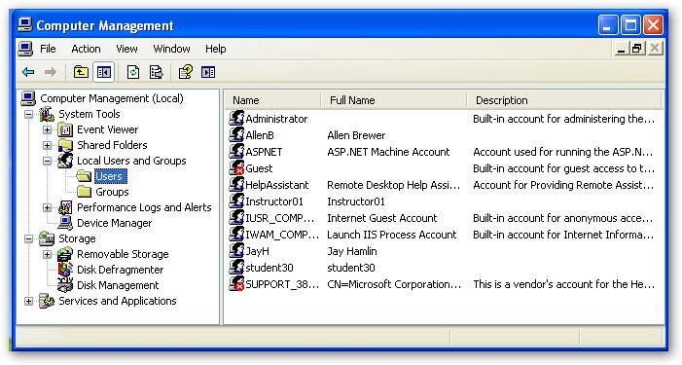
- From the Action menu, select New User.
- In the New User dialog box, in the User Name text box, type SteveL.
- In the Full Name text box, type Steve Lasker.
- Clear the User Must Change Password At Next Logon check box.
- Select the Password Never Expires check box.
Note: It is not a good practice to create passwords that do not expire, and it is better to force the user to change the password at logon so that it is not known to administrators. The method used here is only for convenience in the lab.
- In the Password and Confirm Password text boxes, type P@asswOrd. The following figure shows the correct configuration.
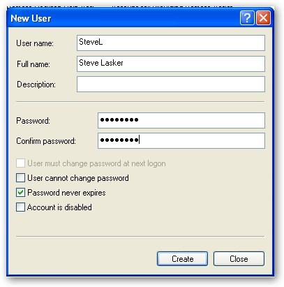
- Click Create
- Create two more accounts, using the same settings as in the previous account and using information from the following table.
Full Name User Name Password
Douglas Curran DouglasC P@sswOrd
Bob Kelly BobK P@sswOrd
- In the New User dialog box, click Close.
- Leave the Computer Management Console open for the next task.

Creating Groups and Adding Users to Groups
The following steps will create the Bldgl Users group and add BobK and DouglasC to it, using two different methods to demonstrate the different ways in which the task can be completed.
- In the Computer Management console, in the console tree, select Groups.
- From the Action menu, select New Group.
- In the New Group dialog box, in the Group Name text box, type Bldg1 Users and then click Create. Click Close.
- In the Computer Management Console, double-click Bldg1 Users.
- In the Bldg1 Users Properties dialog box, click Add.
- In the Select Users Or Groups dialog box, in the Enter The Object Names To Select (Examples) text box, type Computerxx\DouglasC .
- Click Check Names.
- Click OK.
- In the Bldg1 Users Properties dialog box, click OK.
- In the Computer Management Console, in the console tree, select Users.
- In the details pane, double-click BobK.
- In the BobK Properties dialog box, on the Member Of tab, click Add.
- In the Select Users Or Groups dialog box, in the Enter The Object Names To Select (Examples) text box, type Bldg1 Users.
- Click Check Names.
- Click OK.
- In the BobK Properties dialog box, select Users and then click Remove. Click OK.
- Close the Computer Management console.
Testing a New Account
The following steps will install the Support Tools, which contain a utility named Whoami, which is a convenient way of accessing the information for the current user.
Note: before you begin the following steps, load your Microsoft Windows XP installation CD into the CD-ROM drive. If the Welcome To Microsoft Windows XP window appears, close it.
- Insert the Windows XP Professional disk into the CD/DVD drive
- Close any installation window that appears
- From the Start menu, select My Computer.
- Right-click on New(d:) and select open
- In the My Computer window, Browse to D:\support|\tools.
- Double-click Suptools.msi.
- In the Windows Support Tools Setup Wizard, on the Welcome page, click Next.
- On the End User License Agreement page, select I Agree and then click Next.
- On the User Information page, click Next.
- On the Select An Installation Type page, select Complete and then click Next.
- On the Destination Directory page, accept the default location by clicking Install Now.
- The Installation Progress page will appear and indicate progress.
- On the Completing the Windows Support Tools Setup Wizard page, click Finish.
- Close all Open windows.
- Remove the Windows XP installation disk.
- From the Start menu, select Run.
- In the Run dialog box, in the Open text box, type cmd and then press ENTER.
- In the command prompt window, at the command prompt, type whoami and then press ENTER.
Question 1: What is the answer to the question?
- Log off and log back on as SteveL.
Question 2: Why does it take longer for SteveL’s desk top to completely appear?
- From the Start menu, select Run
- In the Run dialog box, in the Open text box, type cmd and then press ENTER.
- In the command prompt window, at the command prompt, type whoami.
Question 3: What reply is displayed when you execute the Whoami command this time?
- Close the command prompt window.

Exercise 13-2: Assigning Users Rights
Now that you have created several users and added some of them to a new group, you need to assign rights to these users and groups. The multiuser computer has a clock that runs slow and drifts about 10 minutes every day. You need to allow SteveL, who uses the computer each morning, to change the system time. (You cannot synchronize the system time with an online source because the computer has no Internet connection.)
Assigning User Rights by User
The following steps will assign the Change The System Time right to SteveL.
- Double-click the clock in the notification area.
Question 4: What is conveyed in the message that appears?
- In the Date And Time Properties message box, click OK.
- Log off and log back on with your local Administrator account.
- From the Start menu, select Control Panel.
- In Control Panel, click Switch To Classic View.
- Double-click Administrative Tools.
- In the Administrative Tools window, double-click Local Security Policy.
- In the Local Security Settings console, in the console tree, expand Local Policies and then select User Rights Assignment, as shown in the following figure.
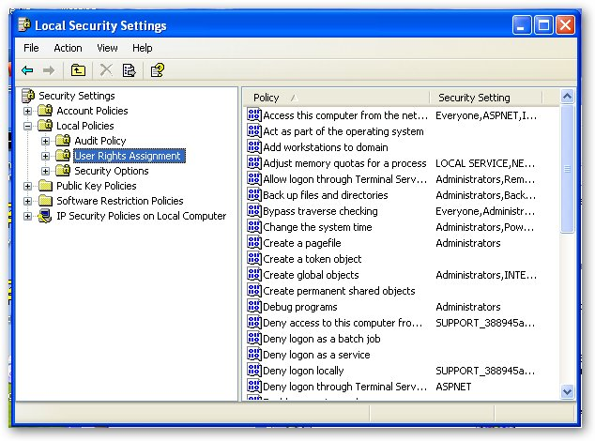
- In the details pane, double-click Change The System Time.
- In the Change The System Time Properties dialog box, click Add User Or Group.
- In the Select Users Or Groups dialog box, in the Enter The Object Names To Select (Examples) text box, type Computerxx\SteveL.
- Click Check Names.
- Click OK.
Question 5: What users and or groups now have the rights to change the system time?
- In the Change The System Time Properties dialog box, click OK.
- Close all windows.
- Log off and log back on locally as SteveL.
- Double-click the time in the notification area.
Question 6: Why do you now have the ability to change the date and time?
- Close the Date And Time Properties dialog box.
- Log off.

Assigning Rights to Groups
Although it is possible to assign rights to users directly, it is most often better to assign rights to groups, and to then make users members of the groups as appropriate. This greatly simplifies auditing user rights and can eliminate a lot of work.
The following steps assign the Bldg1 Users group to a set of rights similar to that of the Users group.
- Log on with your local Administrator account.
- From the Start menu, select Control Panel.
- Double-click Administrative Tools.
- In the Administrative Tools window, double-click Local Security Policy.
- In the Local Security Settings console, in the console tree, expand Local Policies and then select User Rights Assignment
- In the details pane, double-click Log On Locally.
Question 7: What users and groups have access to this user right?
- In the Log On Locally Properties dialog box, click Add User Or Group.
- In the Select Users Or Groups dialog box, click Object Types.
- In the Enter Network Password dialog box, click Cancel.
- In the Object Types dialog box, select the Groups check box and then click OK.
- In the Select Users Or Groups dialog box, in the Enter The Object Names To Select (Examples) text box, type Computerxx\Bldg1 Users.
- Click Check Names.
- Click OK.
- In the Log On Locally Properties dialog box, click OK.
- Use the same technique to assign the Bldg1 Users group to the following rights. (These are the same rights to which the Users group is assigned, not including the Shut Down The System right.) Computerxx\Bldg1 Users
- Access This Computer From The Network
Question 8: What warning message appears when you complete the process of adding the group Bldg1 Users to the Right?
Click Yes to Continue.
- Bypass Traverse Checking
- Remove Computer From Docking Station
- Close all windows.
- Log off.

Understanding User Rights Application
The following steps will test the rights assignment that you completed in the previous task.
- Log on locally as BobK.
- From the Start menu, select Shut Down.
Question 9: The Members Of tab in the Security Properties dialog box states that BobK is a member only of the Bldg1 Users group. We did not assign the Bldg1 Users group to the Shut Down The System right, so why is the Shut Down option available in the drop-down list?
- In the Shut Down Windows dialog box, click Cancel.
- From the Start menu, select Control Panel.
- In Control Panel, click Switch To Classic view.
- Double-click Administrative Tools.
- Right-click Local Security Policy, and then select Run As.
- In the Run As dialog box, select The Following User.
- In the User Name text box, type Computerxx\Administrator (this should already be in the box).
- In the Password text box, type P@sswOrd and then click OK.
- In the Local Security Settings console, in the console tree, ensure that User Rights Assignment is selected.
- In the details pane, double-click Shut Down The System.
- In the Shut Down The System Properties dialog box, select Users, and then click Remove. Click OK.
- Close all windows.
- Log off and log back on locally as BobK.
- From the Start menu, select Shut Down.
Question 10: What options are available in the Shut Down Windows dialog box and why did they change?
- Click Cancel.
- Log off.

Exercise 13-3: Configuring Roaming Profiles
Creating a Roaming Profile
A multiuser workstation is short on disk space, and to free space you want all of the users' documents and settings files to be stored on a file server. To accomplish this, you need to configure a roaming profile.
- Log on locally with your Administrator account.
- Open the Computer Management console (control panel\System Tools\Computer Management).
- In the Computer Management console, under System Tools, expand Shared Folders and then select Shares.
- From the Action menu, select New File Share.
- In the Create A Shared Folder Wizard, on the Welcome page, click Next.
- On the Set Up A Shared Folder page, in the Folder To Share text box, type C:\ Bldg1Profiles\ SteveL.
- In the Share Name text box, type SteveL. The correct configuration for Computer30 is shown in the following figure.
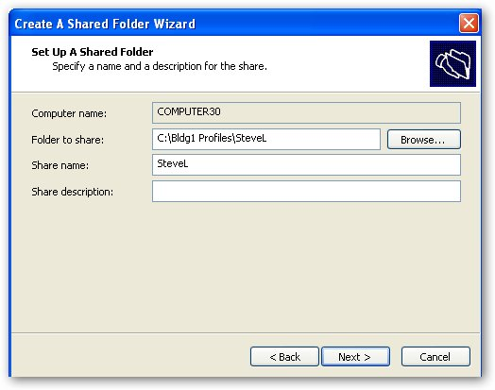
- Click Next.
- In the Create A Shared Folder Wizard message box, click Yes to create the folder.
- On the Shared Folder Permissions page, select Customize Permissions and then click Custom.
- In the Customize Permissions dialog box, ensure that Everyone is granted Full Control and then click OK.
- On the Shared Folder Permissions page, click Next.
Question 11: Which network users have access to this folder?
- On the Completing The Create A Shared Folder Wizard page, click Finish.
- In the Computer Management console, expand Local Users And Groups and then select Users.
- In the details pane, double-click SteveL.
- In the SteveL Properties dialog box, on the Profile tab, in the Profile Path text box, type \ \Computeryy\SteveL and then click OK.
- Close the Computer Management console.
- From the Start menu, select Run.
- In the Run dialog box, in the Open text box, type gpedit.msc and then press ENTER.
- In the Group Policy console, under Computer Configuration, expand Administrative Templates, System, and then select User Profiles.
- In the details pane, double-click Do Not Check For User Ownership Of Roaming Profiles Folders.
- In the Do Not Check For User Ownership Of Roaming Profiles Folders Properties dialog box, select Enabled. Click OK.
Note: If we were configuring roaming profiles’ through the Group Policy of a domain, step 21 would not be necessary (assuming that the ownership settings were correctly configured).
- Close the Group Policy console.
- Log off.

Testing the Roaming User Profile
The following steps will test the roaming profile that you created in the previous task.
IMPORTANT Wait until your partner has completed the previous task before continuing.
- Log on locally as SteveL.
- From the Start menu, select My Computer.
- In the My Computer window, double-click Local Disk (C:).
- In the Local Disk (C:) window, in the System Tasks pane, click Show The Contents Of This Drive.
IMPORTANT Wait until your partner has logged on as SteveL before continuing.
- Double-click Bldg1Profiles, and then double-click SteveL.
Question 12: Why are no files saved in the SteveL folder when we have specified that as the location for profile data for your partner's 5teveL local account?
- Log off and log back on locally with your Administrator account.
- From the Start menu, select My Computer.
IMPORTANT Wait until your partner has logged off from SteveL before continuing.
- In the My Computer window, browse to C:\Bldg1Frofiles\SteveL.
Question 13: Are there files in this folder now?
- Close the SteveL window.

Lab Review Questions
1. Do you add users to a group by accessing the user's properties or by accessing the group's properties?
2. Eight users from disparate groups require NTFS permissions to read and write to files in a shared folder located on a file server. The users are from varying groups and have varying permissions and rights. What is the best way to give them access to the folder?
3. You add a user to a group that you have created with a specific set of rights for a new project. How can adding the user to this group affect the user's membership in other groups?
4. It is conventional to state that rights are assigned to users or groups. How is this incorrect?
5. You want members of the Contoso domain to be able to access their desktops no matter where they log on from into the domain. What do you need to configure to accomplish this?

